

AFfinity

Education


OPEN THE DOOR TO SUCCESS
2026年雅思口语1月新题速递

2026.1.6更新
安飞尼迪教育
AFfinity Education



安飞尼迪教育王牌雅思项目汇总


Part 1新题
*部分题目来自网络，可能会有出处，此版本为尝鲜版，仅供参考

1.Day off (休息日)
1.When was the last time you had a few days off?
2.What do you usually do when you have days off?
3.Do you usually spend your days off with your parents or with your friends?
4.What would you like to do if you had a day off tomorrow?

2.Reading (阅读)
1.Have you read any books lately?
2.Do you prefer speed reading or thoughtful reading?
3.Why do some people like speed reading?

3.Pets and Animals (宠物与动物)
1.What's your favourite animal?Why?
2.Where do you prefer to keep your pet,indoors or outdoors?
3.Did you have any pets when you were a child?
4.What is the most popular animal in China?

4.Morning Time (早晨时光)
1.Do you like getting up early in the morning?
2.What do you usually do in the morning?
3.What did you do in the morning when you were little?Why?
4.Are there any differences between what you do in the morning now and what you did in the past?
5.Do you spend your mornings doing the same things on both weekends and weekdays?Why?

5.Walking (散步)
1.Do you walk a lot?
2.Did you often go outside to have a walk when you were a child?
3.Why do people like to walk in parks?
4.Where would you like to take a long walk if you had the chance?
5.Where did you go for a walk lately?

2

安飞尼迪教育王牌雅思项目汇总



AFfinity Education
安飞尼迪教育

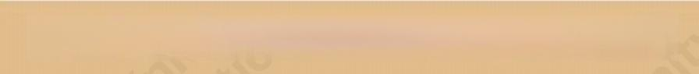
语 言 提 升 一 站 式 服 务

6.Keys (钥匙)
1.Do you always bring a lot of keys with you?
2.Have you ever lost your keys?
3.Do you often forget the keys and lock yourself out?
4.Do you think it's a good idea to leave your keys with a neighbour?

7.Sports Team (运动队)
1.Have you ever been part of a sports team?
2.Do you enjoy being in a team more than playing alone?Why?
3.How do your teammates help you improve your skills?
4.Have you ever been the captain of a sports team?
5.What qualities make a good captain in your opinion?

8.Food and Cooking (食物与烹饪)
1.What is your favorite food?
2.Is there any food you dislike?
3.What kind of new food would you like to try?
4.Who normally does the cooking in your home?
5.In general,do you prefer eating out or eating at home?

9.Gifts (礼物)
1.Have you ever sent handmade gifts to others?
2.Have you ever received a great gift?
3.What do you consider when choosing a gift?
4.Do you think you are good at choosing gifts?
5.What gift have you received recently?


10.Hobby (爱好)
1.Do you have any hobbies?
2.Did you have any hobbies when you were a child?
3.Do you have a hobby that you've had since childhood?
4.Do you have the same hobbies as your family members?

11.Books and reading habits (书籍与阅读习惯)
1.Do you often read books?When?
2.Are your reading habits now different than before?
3.Have you ever read a novel that has been adapted into a film?
4.Which do you prefer,reading books or watching movies?
5.Do you read more or less now than when you were younger?

12.Dreams (梦想/梦境)
1.Can you remember the dreams you had?
2.Do you share your dreams with others?(or are you interested in others' dreams?)
3.Do you think dreams have special meanings?
4.Do you want to make your dreams come true?

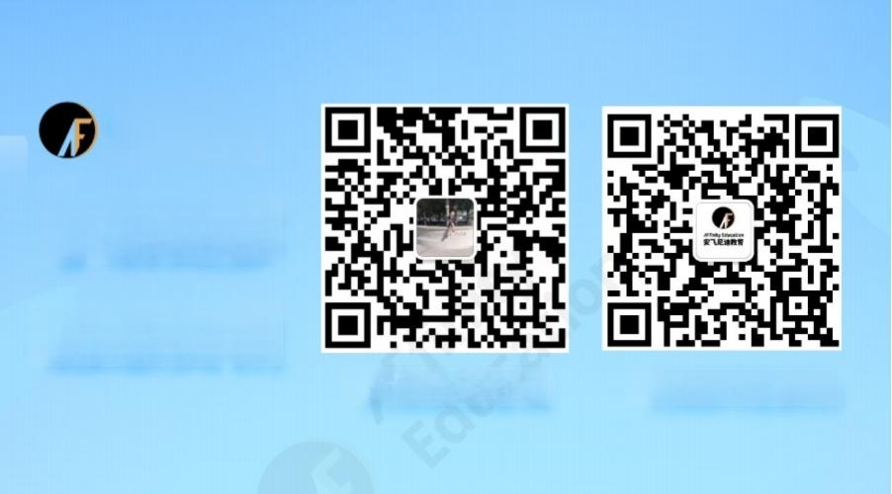

AFfinity
Education
了解更多 雅思资讯
长按添加咨询 扫码关注我们

安飞尼迪教育王牌雅思项目汇总



Part 2&3 新 题

1. 「人物」让你骄傲的家人(更新题目要求)

· Part 2:
Describe a family member who you are proud of You should say:

· Who this person is
· How often you spend time together
· What he/she does that makes you feel proud
· And explain why you are proud of him/her

· Part 3:
o What would children do to make their parents proud?
o What did you do to make your parents proud when you were young?
o What advantages of yours make you proud?
o When was the last time that you felt proud of yourself?

2. 「人物」鼓励你保护自然的人

● Part 2:
Describe a person who encouraged you to protect the nature.
You should say:
· Who this person is
· How you knew this person
· What he/she said or did to encourage you
· And explain how you felt about it.

· Part 3:
o How do people protect the environment?
o Do you think it's important to protect the wild animals/nature?
o What are the main environmental problems in your country?
o Do you think we should use more renewable energy?

3. 「地点」想短期停留或工作的外国国家

· Part 2:

Describe a foreign country you would like to stay or work for a short period of time You should say:


·Which country it is
· Where you got to know this country
· What you will do there
· Why you will stay or work there just for a short period of time

· Part 3:
o Why do people sometimes go to other cities or other countries to travel?
o Is it good for young people to have the experience of living in other countries?
o Why are some people unwilling to work in other countries?
o What kind of work can young people do in foreign countries?
o What is the difference between working in an international company and working in a domestic one?

4. 「物品」想拥有的一项科技产品(非手机)

● Part 2:
Describe a piece of technology(not a phone)that you would like to own You should say:
· What it is
· How much it costs
· What you will use it for
· And explain why you would like to own it

· Part 3:
o What are the differences between the technology of the past and that of today?
o Do you like to use new technology?
o Does technology deeply affect people's lives?
o Is there any difference between technology in cities and in small towns?
o Do you agree that men are more obsessed with new technology than women?
o How to teach the older generation to use new technology?
o Do you think that technology always has positive effects?

5. 「人物」善于制定计划的人

· Part 2:

Describe a person who makes plans a lot You should say:



· Who he/she is
· How you knew him/her
· What plans he/she makes
· And explain how you feel about this person

· Part 3:
o Do you think it's important to plan ahead?
o Do you think children should plan their future careers?
o Should children ask their teachers or parents for advice when making plans?
o What kind of plans do young people often make?
o Why can't people always follow their plans?

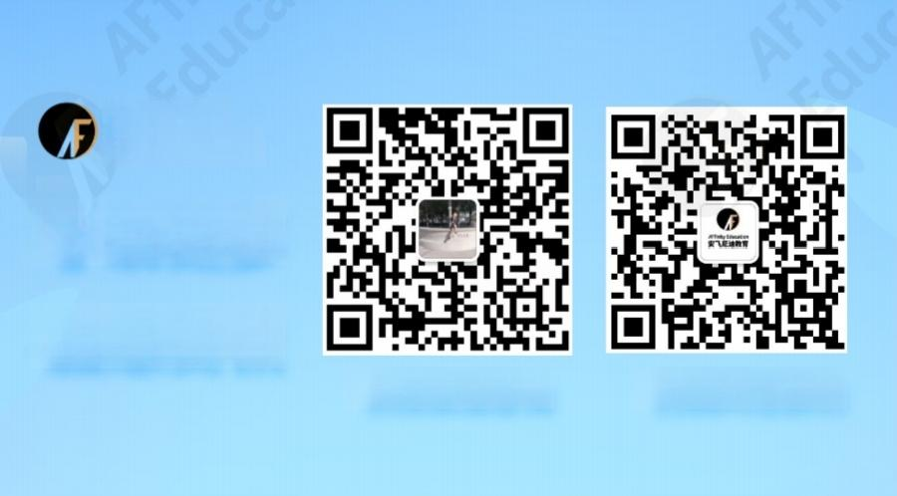

AFfinity
Education
了解更多 雅思资讯
长按添加咨询 扫码关注我们

6. 「人物(儿童)」热爱绘画的孩子

● Part 2:
Describe a child you know who likes drawing very much You should say:
· How you knew him/her
· What he/she is like
· How often he/she draws
· And explain why you think he/she likes drawing

· Part 3:
o What is the right age for a child to learn drawing?


o Why do most children draw more often than adults do?
o Why do some people visit galleries or museums instead of viewing artworks online?
o Do you think galleries and museums should be free of charge?
o How do artworks inspire people?

7. 「工具」电脑或手机上的程序/应用

· Part 2:
Describe a program or app on your computer or phone You should say:

· What it is
· When/how you use it
· Where you found it
· And explain how you feel about it

· Part 3:
o What are the differences between old and young people when using apps?
o Why do some people not like using apps?
o Which phone app is the most popular in your country?
o Do you think parents should limit the time that their children spend on the phone?
o Do you think people depend on phone apps too much?
o Do you think some apps will help people to study?

8. 「故事」最近读过的故事(如童话等)

● Part 2:
Describe a story(e.g.a fairy tale,etc.)you have read recently You should say:
· What it is about
· When you read it
· Whether you liked it
· And explain what you have learned from it

· Part 3:
o Why do most children like listening to stories before bedtime?
o Is a good storyline important for a movie?
o Do you think films with many celebrities are more likely to be popular?

o What films are popular in China right now?


9. 「经历」给别人提建议的时刻

· Part 2:

Describe a time when you gave advice to others You should say:
· When it was
· To whom you gave the advice
· What the advice was
· And explain why you gave the advice

● Part 3:
o Should people prepare before giving advice?
o Is it good to ask advice from strangers online?
o What are the personalities of people whose job is to give advice to others?
o What are the problems if you ask too many people for advice?

10. 「经历」很多人微笑的场合

● Part 2:
Describe an occasion when many people were smiling You should say:

· When it happened
· Who you were with
· What happened
· And explain why most people were smiling

· Part 3:
o Do you think people who like to smile are more friendly?
o Why do most people smile in photographs?
o Do women smile more than men?Why?
o Do people smile more when they are younger or older?

11. 「经历」不允许使用手机的场合

· Part 2:

Describe an occasion when you were not allowed to use your mobile phone


You should say:
· When it was
· Where it was
· Why you were not allowed to use your mobile phone
· And how you felt about it

· Part 3:
o How do young and old people use mobile phones differently?
o What positive and negative impact do mobile phones have on friendship?
o Is it a waste of time to take pictures with mobile phones?
o Do you think it is necessary to have laws on the use of mobile phones?
o In what occasions are people not allowed to speak loudly?
o What would be the most appropriate age for people to own a mobile phone?

12. 「理想」未来想拥有的完美工作

● Part 2:
Describe a perfect job you would like to have in the future You should say:
· What it is
· How you knew it
· What it looks like
· And explain why you think it is perfect

· Part 3:
o What jobs do children want to do when they grow up?
o What should people consider when choosing jobs?
o Is salary the main reason people choose a certain job?
o Do children like to choose the same profession as their parents?
o Will people regret about their career choices when they become older?

13. 「娱乐」最近看的令人失望的电影

· Part 2:

Describe a movie you watched recently that you felt disappointed about You should say:
· When it was

安飞尼迪教育王牌雅思项目汇总


·Why you didn't like it
· Why you decided to watch it
· And explain why you felt disappointed about it

· Part 3:
o Do you believe movie reviews?
o What are the different types of films in your country?
o Are historical films popular in your country?Why?
o Do you think films with famous actors or actresses are more likely to become successful films?
o Why are Japanese animated films so popular?
o Should the director pay a lot of money to famous actors?

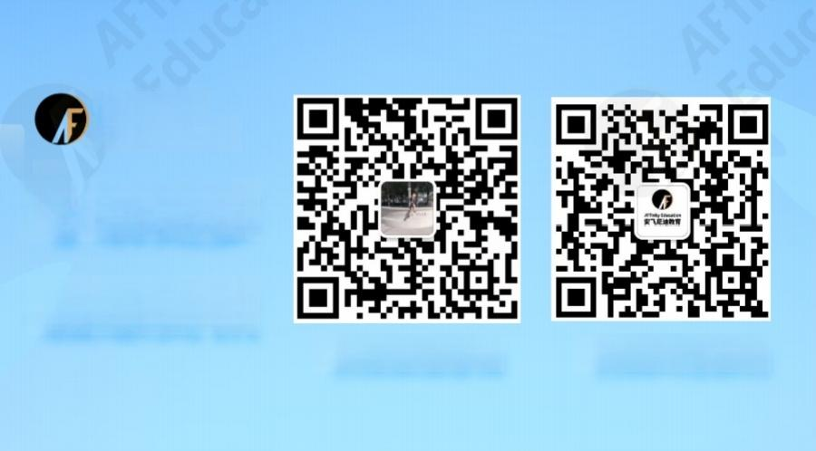

AFfinity
Education
了解更多 雅思资讯
长按添加咨询 扫码关注我们

14 . 「地点(家居)」家中最爱的放松角落

● Part 2:
Describe your favorite place in your house where you can relax You should say:
· Where it is
· What it is like
· What you enjoy doing there
· And explain why you feel relaxed at this place

· Part 3:
o Why is it difficult for some people to relax?


o What are the benefits of doing exercise?
o Do people in your country exercise after work?
o What is the place where people spend most of their time at home?
o Do you think there should be classes for training young people and children how to relax?
o Which is more important,mental relaxation or physical relaxation?

15 . 「人物(名人)」想见到的名人

● Part 2:
Describe a famous person you would like to meet You should say:
· Who he/she is
· How you knew him/her
· How/where you would like to meet him/her
· And explain why you would like to meet him/her

· Part 3:
o What are the advantages and disadvantages of being a famous child?
o What can today's children do to become famous?
o What can children do with their fame?
o Do people become famous because of their talent?
o Do you think media is putting too much attention on famous people?
o What are the differences between famous people today and those in the past?
o Do you think celebrities should necessarily be good at their field?

16. 「物品」离不开的东西(非电脑/手机)

· Part 2:

Describe something that you can't live without(not a computer/phone)
You should say:
· What it is
· What you do with it
· How it helps you in your life
· And explain why you can't live without it

● Part 3:
o Why are children attracted to new things (such as electronics)?
o Why do some grown-ups hate to throw out old things (such as clothes)?


o Is the way people buy things affected?How?
o What do you think influences people to buy new things?
o Why do all children like toys?
o Do you think it is good for a child to always take his or her favorite toy with them all the time?

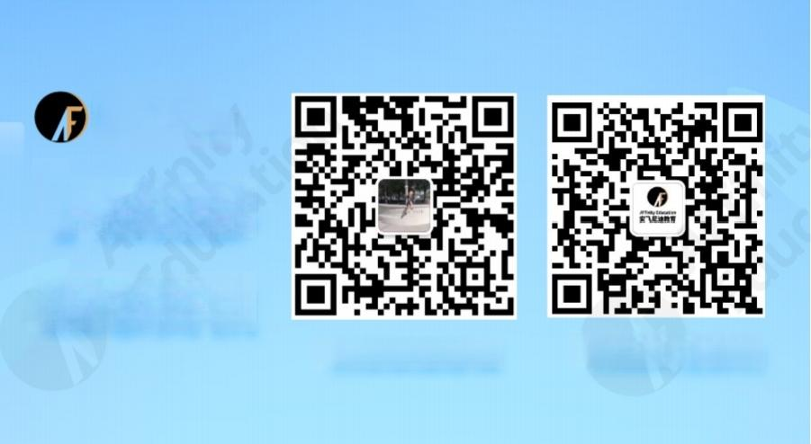

AFfínity
Education
了解更多 雅思资讯
长按添加咨询 扫码关注我们

